27dBm Dual Band 1800+2100MHz Repeater
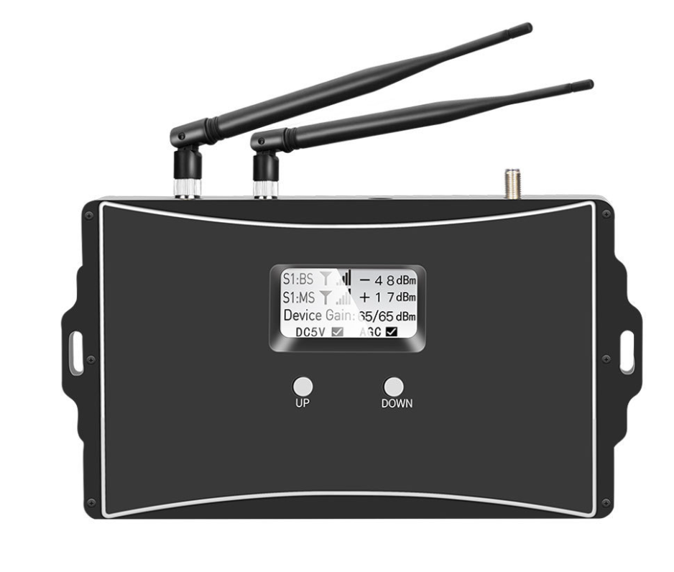
Model: AT-1800+2100

Product Features:
- Improve any two mobile networks at the same time
- LCD display the input/output signal strength
- Auto isolation detect function
- Auto gain control ,auto level control
- Auto uplink noise reduction,avoid disturbing to BTS
- Smart LCD to guide the installation
- Metal industrial design

Working Schematic Diagram
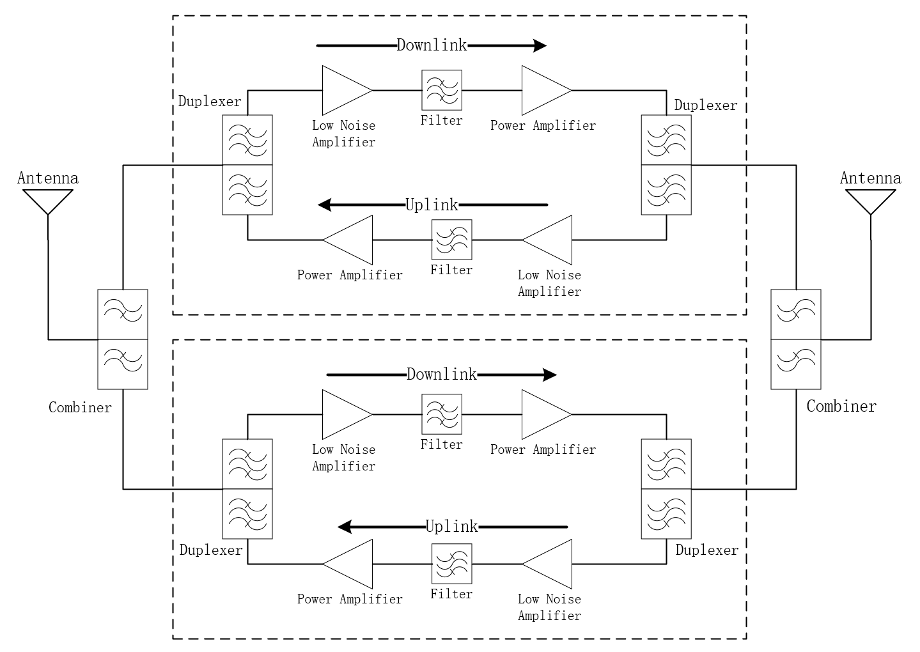

Application Scenario:


Technical Specifications:
P/N: AT-1401-DW |  | B3 (1800MHz) | B1(2100MHz)
Frequency Range | Uplink | 1710 - 1785 MHz | 1920-1980 MHz
Frequency Range | Downlink | 1805 - 1880 MHz | 2110-2170 MHz
Max. Gain | Uplink | 70±3 dB | 70±3 dB
Max. Gain | Downlink | 75±3 dB | 75±3 dB
Manual Gain Control |  | 31 dB in step of 1 dB
Automatic Gain Control |  | ≧ 20 dB
Max. Input Power Without Damage |  | 0 dBm
Output Power | Uplink | 23±2 dBm | 23±2 dBm
Output Power | Downlink | 27±2 dBm | 27±2 dBm
Spurious Emission | 9KHz-1GHz | ≦ -36dBm
Spurious Emission | 1GHz-12.75GHz | ≦ -30dBm
ACRR | ±20/100MHz | ≦-36dBc/30KHz | ≦-36dBc/30KHz
ACRR | ±40/200MHz | ≦-40dBc/30KHz | ≦-40dBc/30KHz
EVM |  | ≦ 8% | ≦ 8%
Frequency Stability |  | ≦ ±0.01 ppm | ≦ ±0.01 ppm
Noise Figure |  | ≦ 9 dB
VSWR |  | ≦ 2
System Delay |  | ≦ 1 .6µs
RF Connector |  | N-Female
Impedance |  | 50 Ω
Power Supply |  | DC 24V
Power Consumption |  | ≦ 120 W
Dimensions |  | 267*235*52cm
Weight |  | ≦ 3 kg
IP Rating |  | IP43
Operating Temperature |  | -25 °C to 80 °C

Technical specification is subject to change without prior notice.

